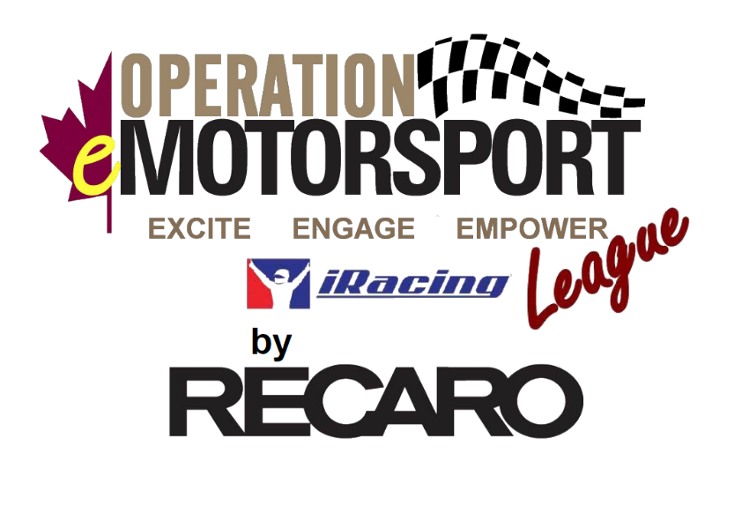

Operation Motorsport is a 501(c)(3) and not-for-profit foundation based in Raleigh, NC and Brighton, Ontario. Founded in 2017, this veteran led and operated foundation utilizes motorsports to engage medically retiring and wounded service members in the United States and Canada. With strong partnerships within sports car race teams across the IMSA, SRO, and CTCC paddocks, Operation Motorsport primarily engages program participants by providing opportunities to immerse into the series as crew members, hospitality, photography/videography, or a number of other positions that support race events. The goals of each activation are:
- Provide a sense of TEAM
- Rebuild a sense of PURPOSE
- Regrow a sense of IDENTIY
In 2020, with the onset of the worldwide Covid-19 pandemic, real-world racing came to a sudden halt and was forced to find other avenues to engage their fanbase and teams. As with other series, Sim Racing/eSports saw an explosion in membership and activity.
Operation Motorsport took notice and needed an avenue to engage their program participants stuck at home. After a 6-race test run, Operation Motorsport saw interest and potential growth opportunities while increasing it’s reach within the veteran and medically retired military community.
In the summer of 2020, the first 8-week race season was announced using the Mazda MX-5 Global Cup car. In partnership with RECARO as a league sponsor, the Operation eMotorsport League was born using the iRacing platform. Taking place on Tuesday nights, this single car season was chosen as it provided a good foundation for sim-racing rookies while also providing some challenge to experienced racers and bringing many back to where their virtual sim racing life began. Each race consisted of a 45-min practice, 15-min open qualifier, and 60-min sprint race with one mandatory fuel stop. The series consisted of three classes: 1) Beneficiary Class 2) Open Class 3) Pro Class. PitStop TV broadcasted each race across multiple social media channels.
The Beneficiary Class consisted of Operation Motorsport program participants. With support from RECARO, any iRacing costs (membership and content) were covered by Operation Motorsport.
The Open Class consisted of Operation Motorsport volunteers, staff, supporters, serving military members, and veterans.
The Pro Class was reserved for licensed (current or previous) IMSA, SRO, CTCC, or other professional race car drivers.
The race schedule mimicked IMSA, SRO, and CTCC when possible and had support from various tracks in the form of prize packages for the top tiered drivers in each class. Further, each driver accumulated points which led to the top driver winning a RECARO seat at the end of the season while the top three in each class received a trophy, with financial support from REDCOM, designed by Racing Recognition; the same supplier to IMSA and SRO. The goal was to blur the lines between virtual and real and give the Beneficiary Class a chance to have the same type of hardware sitting on their shelf that real world race car driver win.
With the success of first season, season two saw an increase in participants across all classes. The general premise stayed true to the original intent with minor tweaks to include expanding the Pro Class to include iRacing drivers with higher SR and IR ratings, an introduction of multicar options (Porsche Cayman GT4 or BMW M4 GT4), and an addition of two 2-hour long races.
Operation Motorsport also ventured into endurance racing with a one-off virtual Race of Remembrance in November 2020. With the real-world Race of Remembrance cancelled due to the pandemic, Operation Motorsport ran a 6-hour, multi-driver team event from virtual Sebring International Raceway with participants from North America, the UK, Germany, and Hungary. This event kicked-off with a virtual military remembrance ceremony and was another opportunity for military members, veterans, and supporters to virtually come together while remembering what Veterans’ Day / Remembrance Day is all about.
Operation Motorsport is planning to kick-off Season three of their iRacing League in July/August 2021. Although details are not yet announced, the league will continue to visit road racing circuits within iRacing and will likely include more car options. The class structure will remain the same.
As a privately funded foundation, Operation Motorsport relies on the generosity of donors to help support its programs. Some areas where individuals or companies can help:
- League cost sponsorship
- Sim equipment donations to veterans who want to participate but cannot due to a lack of expendable funds
- Prize package/in-kind donations
  - Unused Sim Racing equipment (wheel, pedal, sim rig, etc)
  - Gaming PC
  - Gaming Monitor
To join this iRacing League or learn more about how you can assist, please reach out the Jason Leach, the Race Director, for additional information: jason.leach@operationmotorsport.org
Additional Links
Website: https://operationmotorsport.org/emotorsport
Operation Motorsport Intro: https://www.youtube.com/watch?v=D1mi5uFRcwQ
YouTube (previous PitStop TV Broadcasts): https://www.youtube.com/operationmotorsport

